Quiz- 3 Part- 3 Chapter- 11-12-13

1. Are funds available on a credit card included in a definition of the money supply?

a. Yes, because these funds are included in M2.
b. Yes, because these funds can be used to pay for goods and services.
c. No, because these funds are not a store of value.
d. No, because these funds are hard to measure total credit card spending.

2. Expansionary fiscal policy can cause a rise in real GDP in combination with

a. a decrease in the price level.
b. no change in the price level.
c. an increase in the price level.
d. a decrease in the price level if the aggregate supply curve is upward sloping.

3. During the period from 2001 to 2006, there were several major cuts in personal income tax rates. What effect did these have on the value of the multiplier?

a. They decreased the value of the multiplier.
b. They had no effect on the multiplier.
c. The effect was uncertain.
d. They increased the value of the multiplier.

4. When a bank makes loans with excess reserves, it

a. destroys money.
b. creates money.
c. alters the composition of M1.
d. leaves the money supply unchanged.

5. Assume that the federal government wishes to counteract inflation with a policy that has the smallest impact on the federal budget. Which of the following would you recommend?

a. Decrease transfer payments.
b. Increase personal income taxes.
c. Decrease government purchases.
d. Increase government purchases.
e. Increase transfer payments.

6. If the Fed buys a U.S. Treasury bill from a member of the public, the banking system has

a. more reserves and the money supply tends to fall.
b. less reserves and the money supply tends to fall.
c. more reserves and the money supply tends to grow.
d. less reserves and the money supply tends to grow.

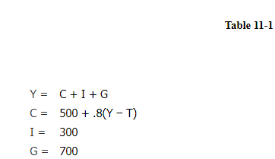

7. Refer to Table 11-1. What is the level of tax revenues in this model?

a. 950
b. 1,000
c. 937.5
d. 437.5
e. 945.5

8. How are Treasury bond prices affected when the interest rate rises?

a. The purchaser of the bond needs to spend less money to obtain a given number of dollars of interest per year, so the price of the bond must decrease.
b. The purchaser of the bond needs to spend more money to obtain a given number of dollars of interest per year, so the price of the bond must decrease.
c. The purchaser of the bond needs to spend more money to obtain a given number of dollars of interest per year, so the price of the bond must increase.
d. The purchaser of the bond needs to spend less money to obtain a given number of dollars of interest per year, so the price of the bond must increase.

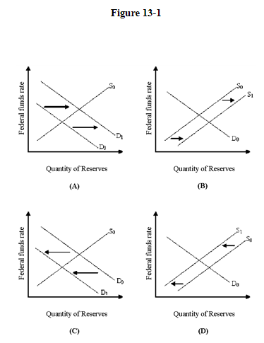

9. In Figure 13-1, which panel shows the effect of a Fed open market sale on the interest rate?

a. Panel (B)
b. Panel (D)
c. Panel (A)
d. Panel (C)

10. An increase in the reserve ratio would tend to

a. increase excess reserves and decrease the money multiplier.
b. increase excess reserves and raise the money multiplier.
c. decrease excess reserves and raise the money multiplier.
d. decrease excess reserves and decrease the money multiplier.

11. Banking under a system of fractional reserves is a(n)

a. fairly safe business with no unusual risks.
b. fairly safe business unless management is irresponsible.
c. inherently risky business that is unsafe regardless of bank management.
d. inherently risky business that is relatively safe under prudent management.

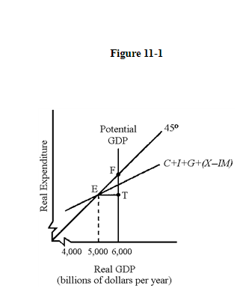

12. In Figure 11-1, the economy is experiencing a(n)

a. inflationary gap equal to EF.
b. inflationary gap equal to ET.
c. recessionary gap equal to FT.
d. recessionary gap equal to ET.

13. If the required reserve ratio, m, is 20 percent, then the oversimplified money multiplier is

a. 5.
b. 10.
c. 2.
d. 4.

14. Which of the following statements is correct?

a. from the customer's point of view, loans to customers are assets of the customer
b. a and d only
c. a and b only
d. from the customer's point of view, loans to customers are liabilities of the customer
e. from the bank's point of view, loans to customers are assets of the bank
f. from the bank's point of view, loans to customers are liabilities of the bank

15. If a "liberal" wanted to decrease aggregate demand, which of the following would she tend to favor?

a. An increase in government spending, because it will increase the size of the public sector.
b. An increase in taxes, because it makes the public sector larger.
c. A decrease in government spending, because it keeps the public sector small.
d. An increase in transfer payments, because it has a larger multiplier than tax changes.

16. of the following is a correct conclusion regarding the successful implementation of fiscal policy?

a. Successful fiscal policy is much easier to achieve today because econometric models make economic forecasting much easier.
b. Successful fiscal policy is difficult to achieve because in the real world the investment, net exports, and consumption schedules are constantly shifting.
c. Successful fiscal policy would be easy to achieve if Congress would stay out of the economy and permit natural market forces to restore full-employment equilibrium.
d. As the income-expenditure model suggests, fiscal policy planners can move GDP to any level they please by changing tax and spending levels.

17. As a general rule, when an income tax is added to the basic macroeconomic model, what happens to the consumption schedule?

a. It will shift downward.
b. It will become steeper.
c. It will become flatter.
d. It will shift upward.

18. If the Fed sells a T-bill to an individual rather than to a commercial bank, how will this affect the money supply?

a. It will increase the checking account balance of the individual.
b. It will increase the money supply.
c. It will decrease the money supply.
d. It will have no effect on the money supply.

19. One of the objectives of supply-side policies is to

a. eliminate the trade-off between inflation and unemployment.
b. sharpen the trade-off between inflation and unemployment.
c. focus attention on the trade-off between inflation and unemployment.
d. convince the public of the trade-off between inflation and unemployment.

20. Banks try to keep their level of excess reserves low because

a. bank regulators levy fines on the amount of excess reserves.
b. the Fed charges a penalty for holdings of excess reserves.
c. they are concerned that the money multiplier will become too large.
d. they wish to maximize profits.

